Title: | DevOps Final Project
Updated: | April 3, 2025 | Due Date: | Midnight before the next class meeting.
Purpose: | The purpose of this lab is to integrate and apply core DevOps concepts, including version control, cloud infrastructure setup, containerized environments, and web deployment, by creating, staging, and hosting a functional website project.  This project assesses all competencies for this course.
Knowledge: | After completing this lab, you will have proved hands-on experience in configuring cloud instances, utilizing Docker for container management, deploying a content management system, and securing a cloud-hosted web service.
Task/Activity: | A. Overview  B. Setup a Repository  C. Create a Cloud Instance  D. Instance Software Setup  E. Clone GitHub Repo  F. Setup Docker Environment  G. Utilize S3 Storage  H. Run a Content Management System  I. Tighten Security  J. Reflection
Criteria for Success: | Success in this lab is marked by accurate task completion, effective analysis, documentation, and clear communication of findings. A crucial aspect involves reflecting on the purpose of the lab, linking procedures to broader concepts, and recognizing the lab's significance within the course.  Overall, success is not only measured by technical proficiency but also by critical thinking, effective communication, and a reflective summary that captures the challenges faced and insights gained throughout the lab experience.
- Overview
Over the course of the term, we have covered version control with git, Linux fundamentals, cloud infrastructure, containerization with Docker, and web and database servers.
This final project will utilize all the skills that you learned to create, stage, and deploy a website.
- Setup a Repository
- Create a repository for your final project. This should be in a new folder somewhere on your computer. Initialize it.
Screenshot | 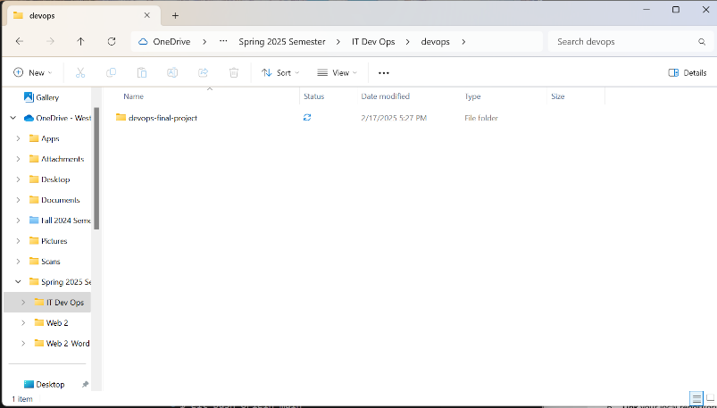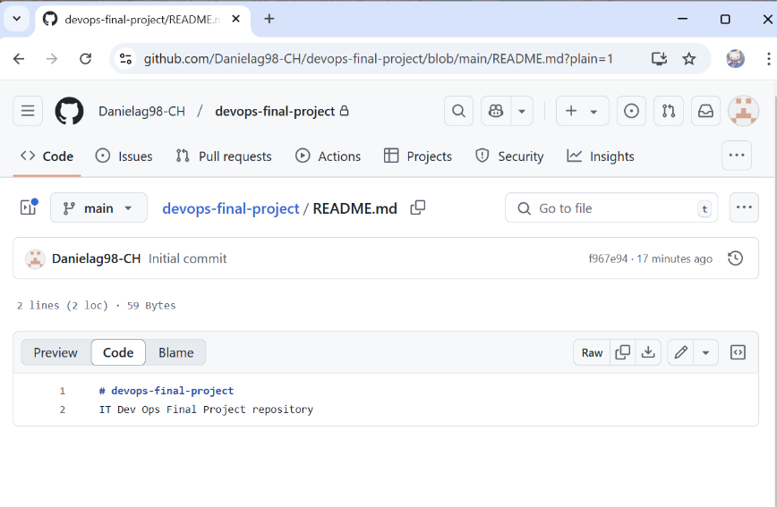  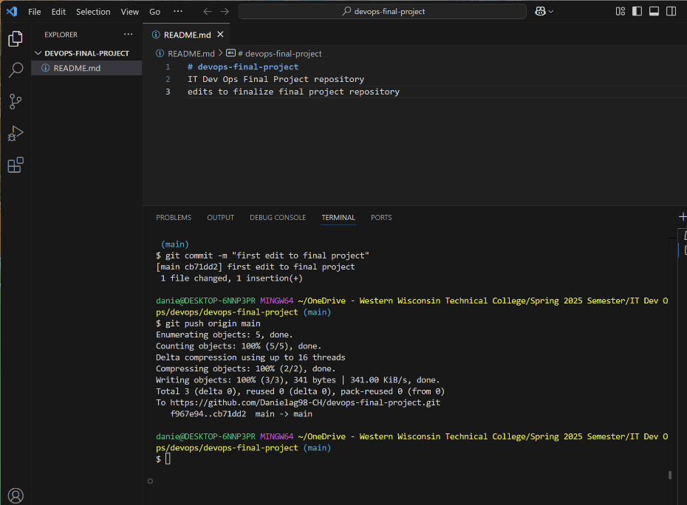
- Create at least one markdown file for each topic (listed below) with some commands that you learned or steps to make something work. This should be a reference document for when you use these tools again. (Markdown Reference: https://www.markdownguide.org/cheat-sheet/)
Topics: Version Control
Linux Fundamentals
Cloud Infrastructure
Containerization
- Create an index.md file that will link to each of the markdown files.
- For a challenge (not required), you can optionally edit an index.html file to redirect to your index.md file. (Hint: HTML redirect)
Code you used
- Stage the files you created, then commit them.
Screenshot | 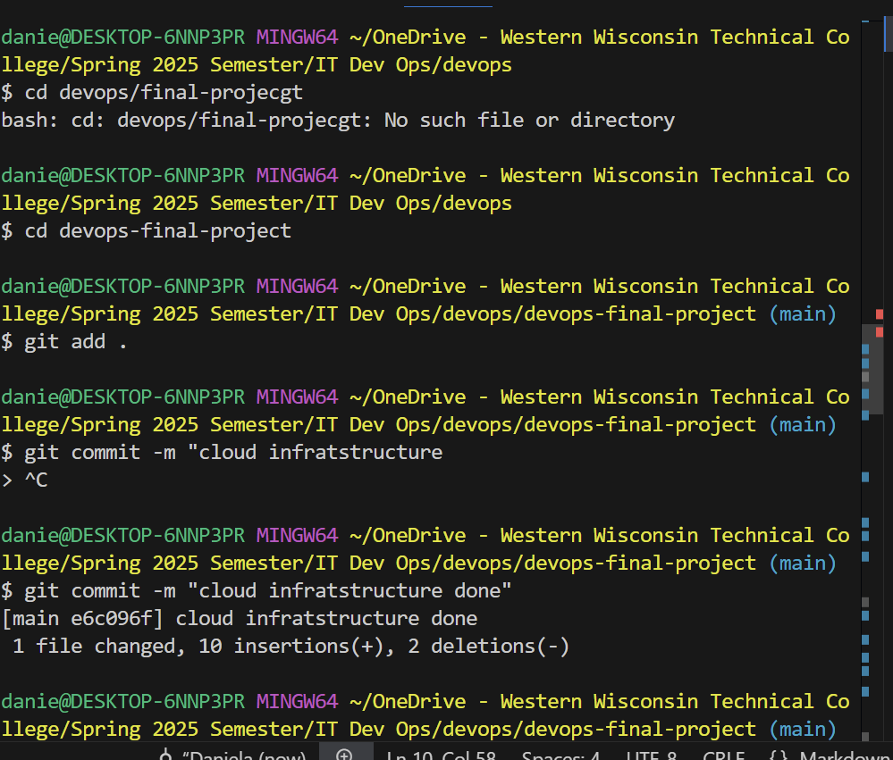
- Link your local repository to a GitHub repo you create for this project.
Screenshot | git@github.com:Danielag98-CH/devops-final-project.git  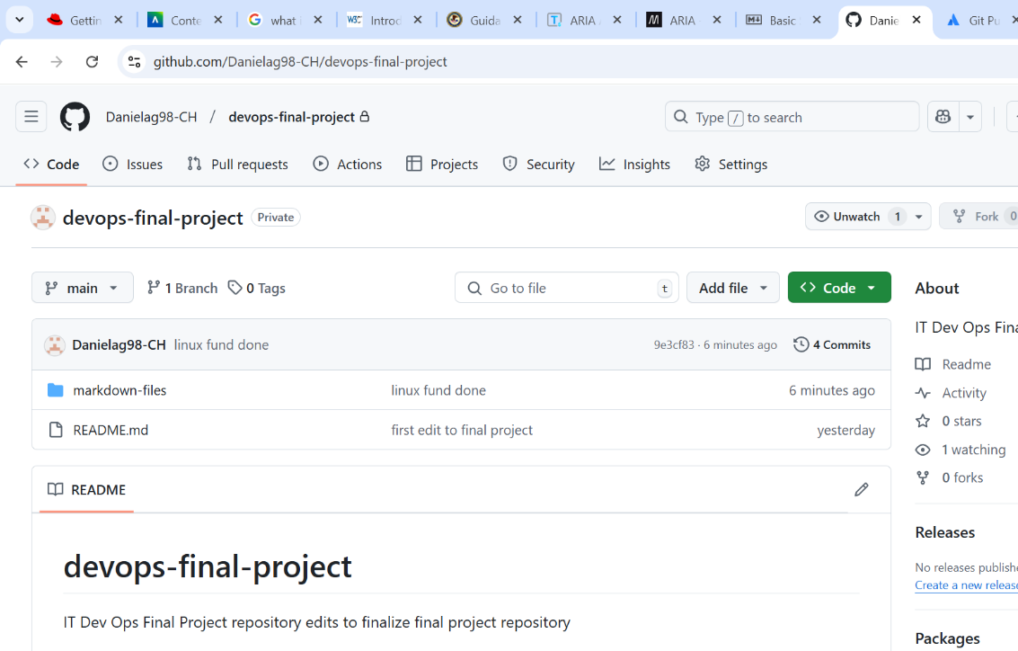
- Push your local changes to GitHub.
Screenshot | 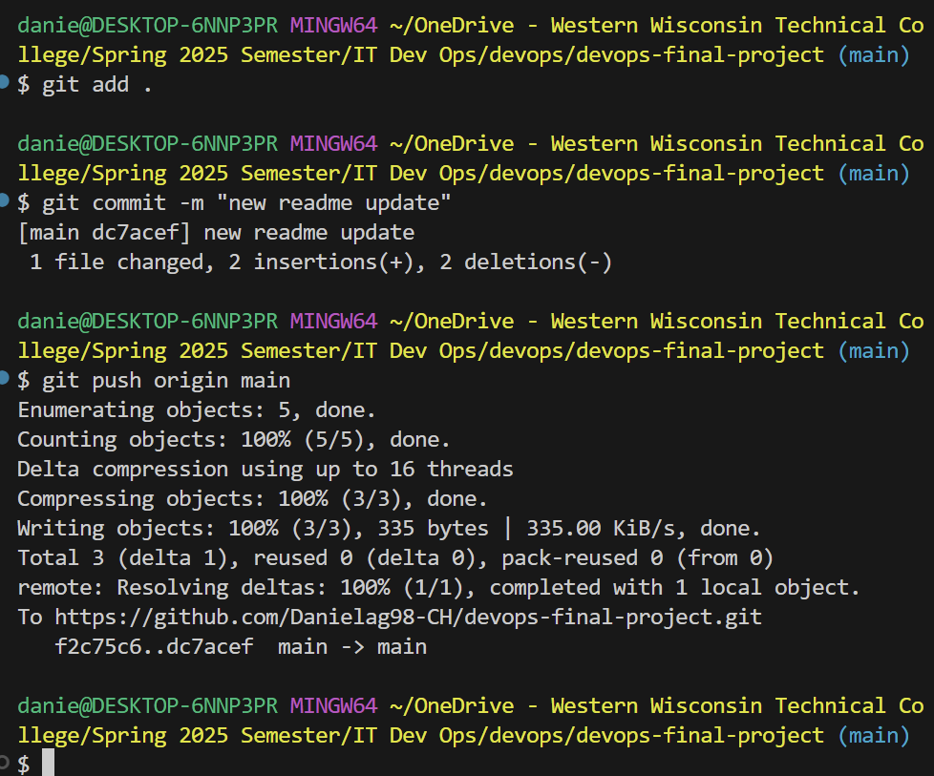
- Verify the markdown files have been pushed to your GitHub repo.
Screenshot | 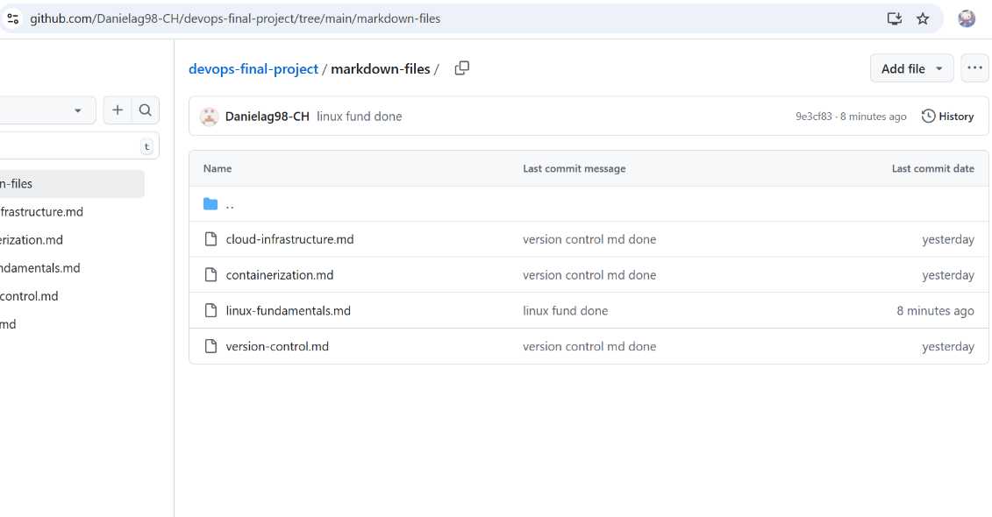
- Create a Cloud Instance
Now that we have our repository setup, we need to create a cloud instance to host our project on.
- Create an EC2 instance using the RedHat OS. Name it “Final Project.”
Screenshot | 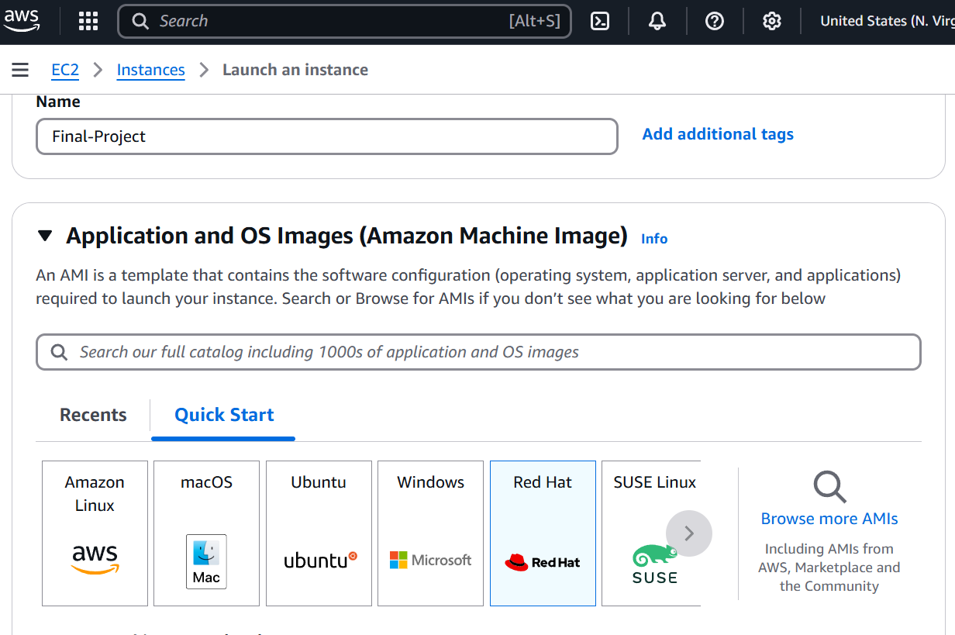
- Create a NEW security key.
Screenshot | 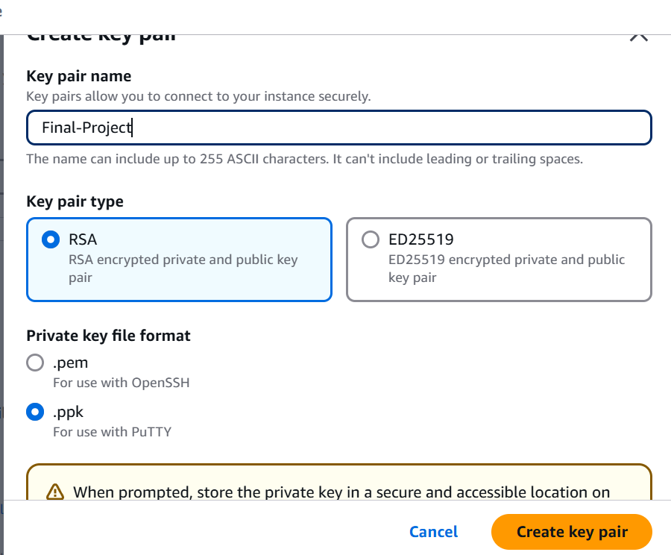
- Launch the instance with no other changes.
- Edit the security group to allow all IPv4 access to all IPv4 addresses.
Screenshot | 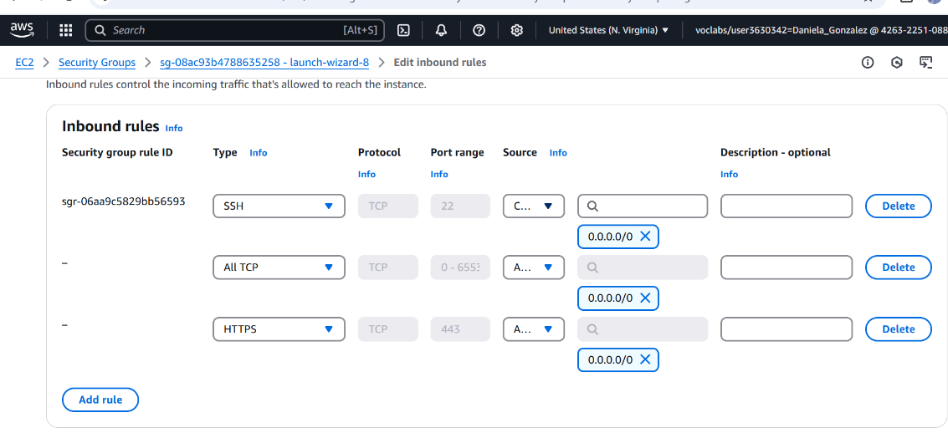
- Configure PuTTY (or your ssh client) to connect to your new instance using your new key.
Screenshot | 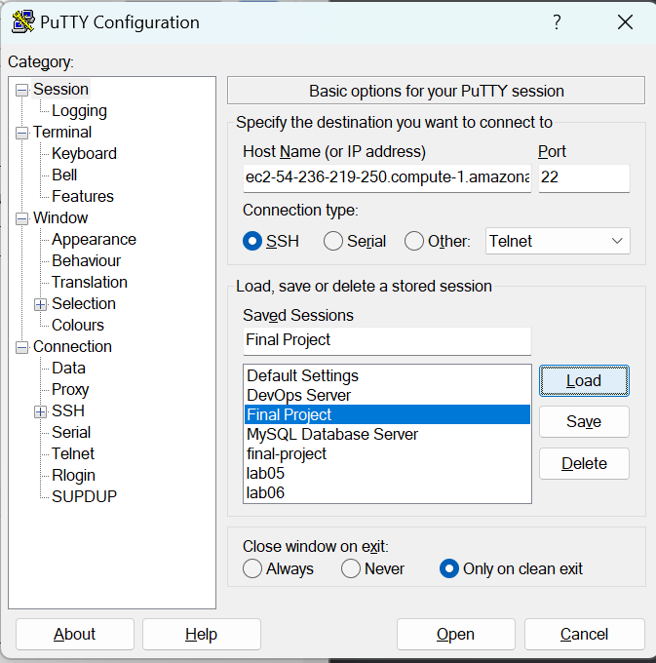
- Make sure that the instance has the latest updates.
Screenshot | 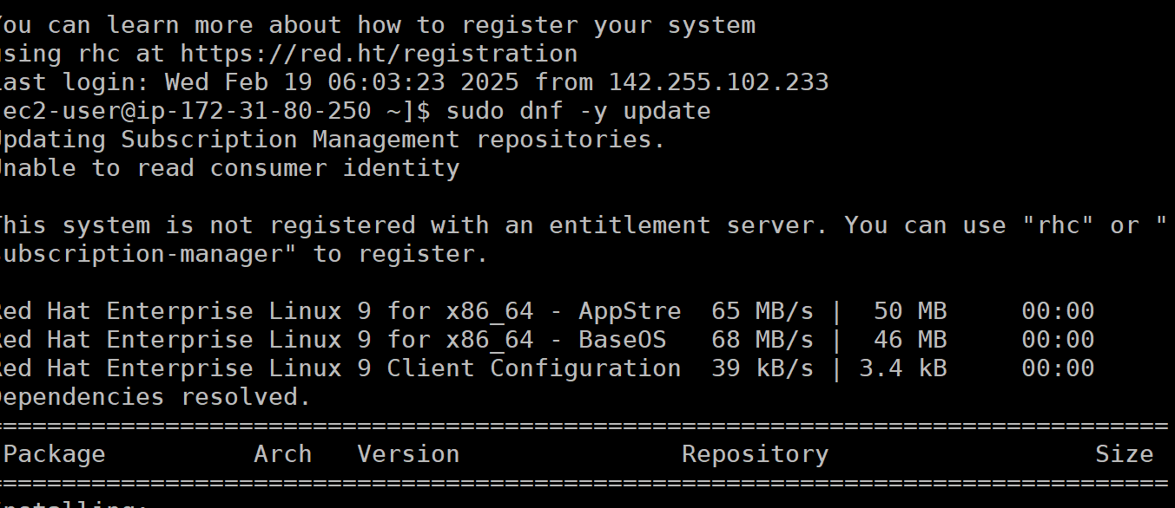  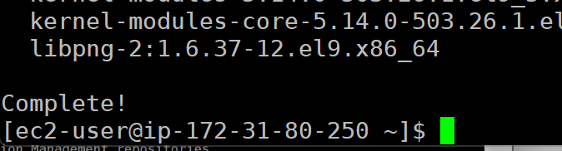
- Instance Software Setup
Now that we are connected to our instance, we need to make sure that we have the software required for the next steps.
- Add the Docker repository.
Screenshot | 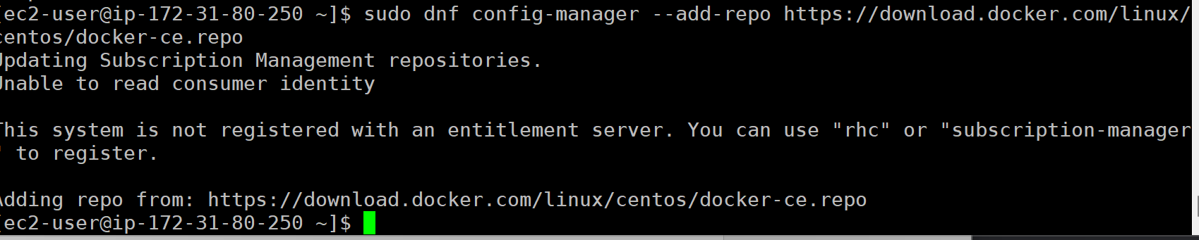
- Install Docker and the needed dependencies.
Screenshot | 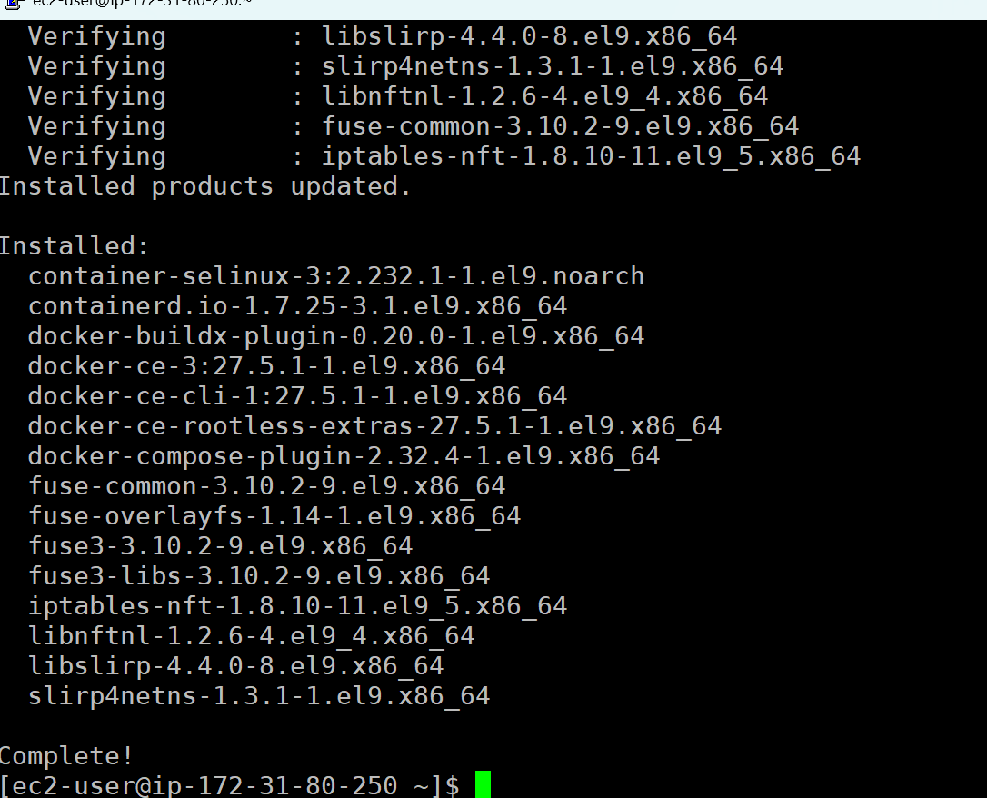
- Install git.
Screenshot | 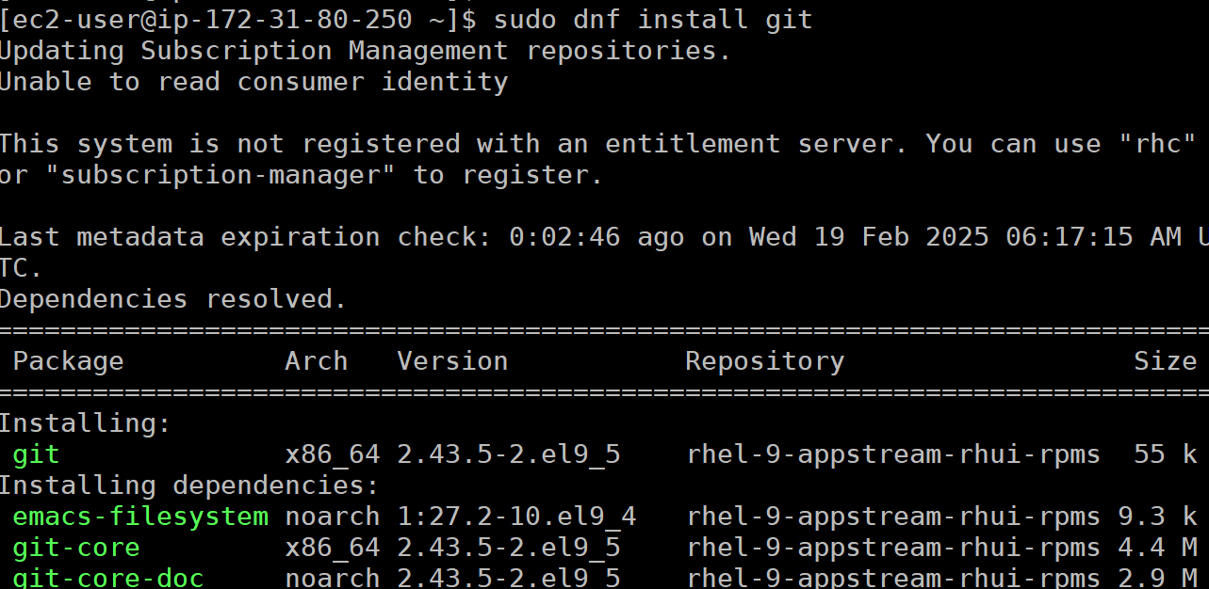  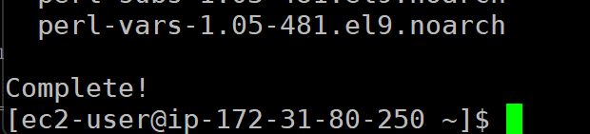
- Clone GitHub Repo
On our instance, we will clone the GitHub repository that we created at the beginning.
- Clone the repo we created earlier to a folder on your instance.
Screenshot | 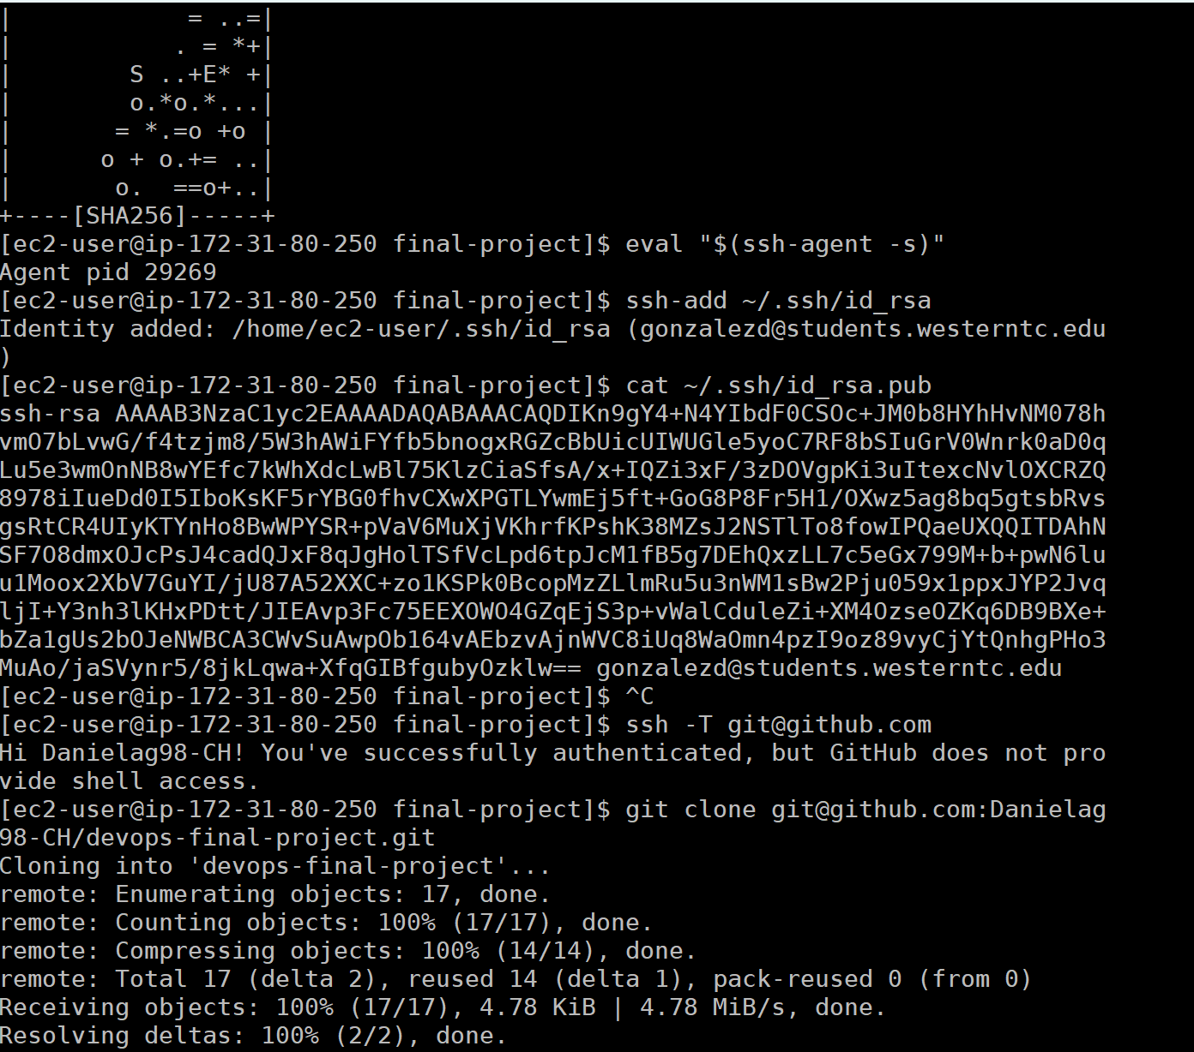
- List the contents of the folder where your repo was cloned into.
Screenshot | 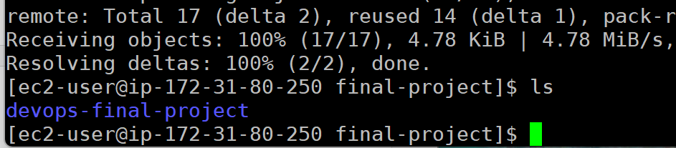
- Take note of the folder (pwd is a good command here) where your repo is located.
/home/ec2-user/final-project
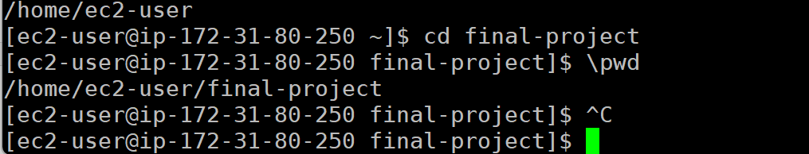
- Setup Docker Environment
We are set to create some Docker containers that will run our website using our markdown files.
- Download the image kobucom/pandoc:local1 from DockerHub with docker.
Screenshot | 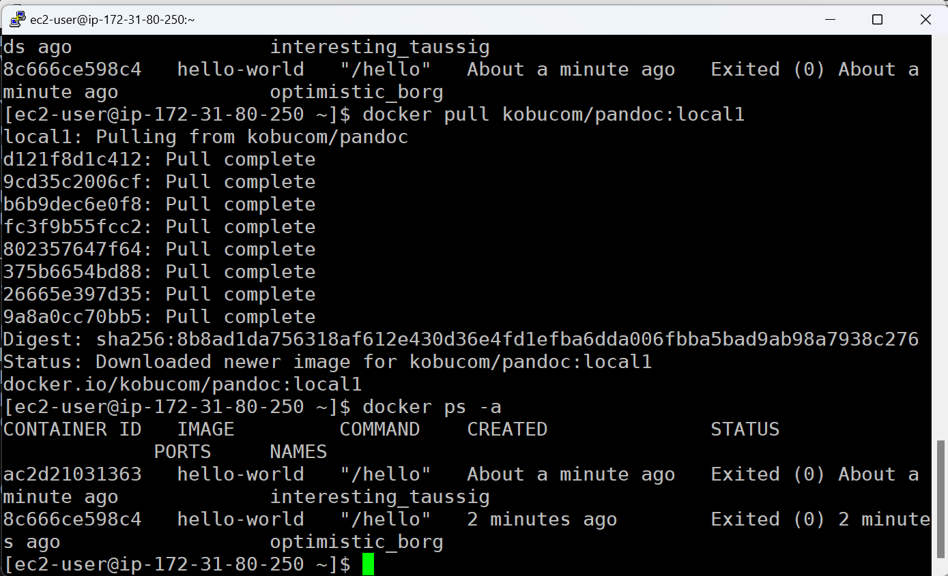
- Run the container on port 8081, detached, named final-project, mapping your GitHub repo directory from above to the /usr/local/apache2/htdocs folder in the container.
Screenshot | 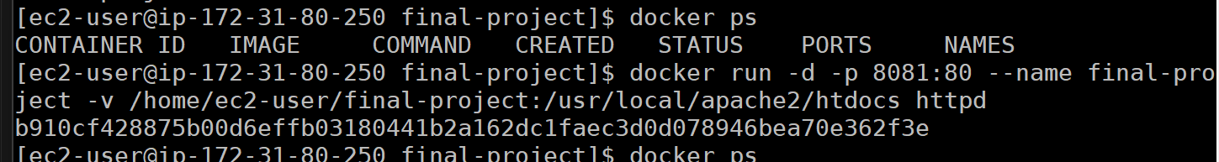
- Make sure the container is running.
Screenshot | 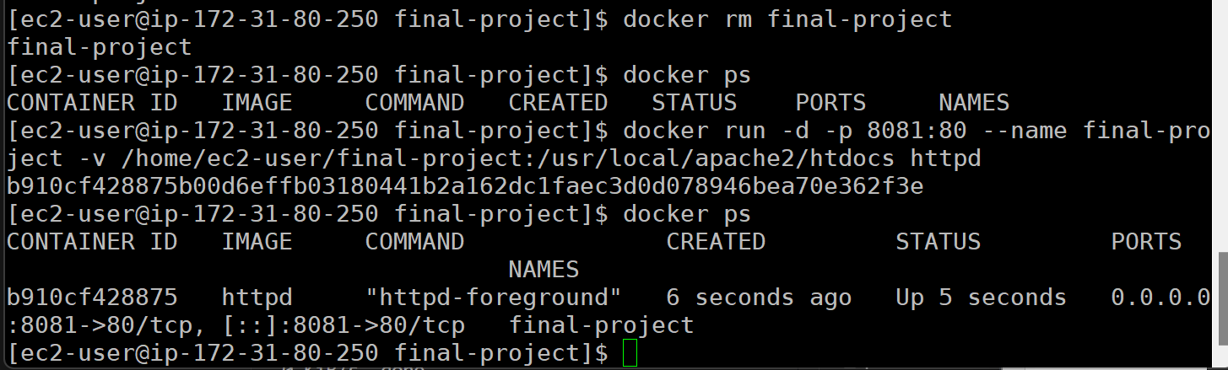
- Navigate to your AWS Public DNS address on port 8081 to see if your files are there.
Screenshot | 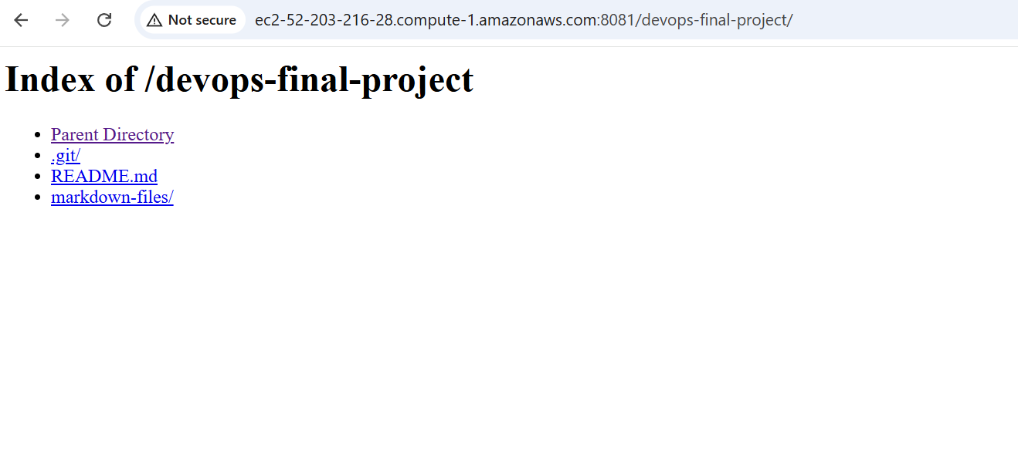
- Utilize S3 Storage
At this point, we should have a working website that is converting our markdown files to nice HTML pages. We can spice this up a bit by including some images.
- Create an S3 bucket with a unique name that has the word “final” in the name.
Screenshot | 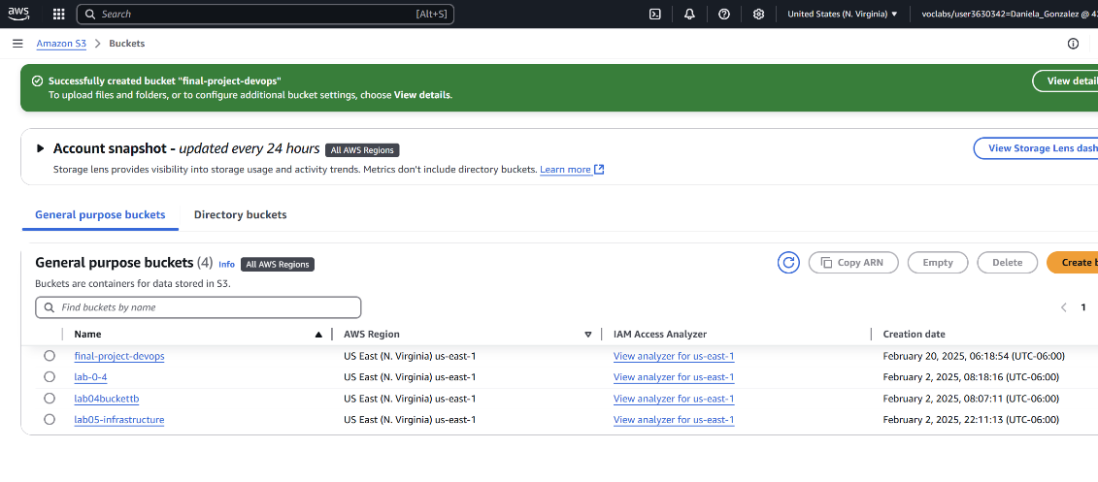
- Allow public access to the bucket.
Screenshot | 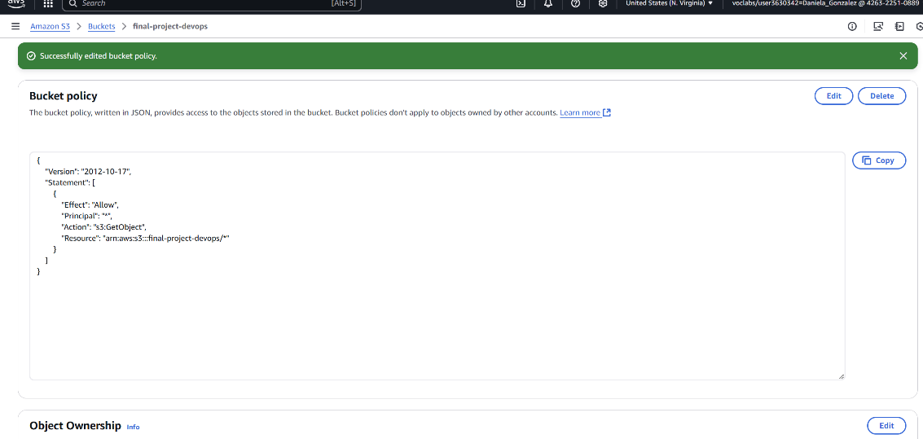
- Take a couple of screenshots that will help show off your documentation you created in the markdown files. (Maybe showing settings in the AWS console, or output of commands, etc)
Screenshot 1 | 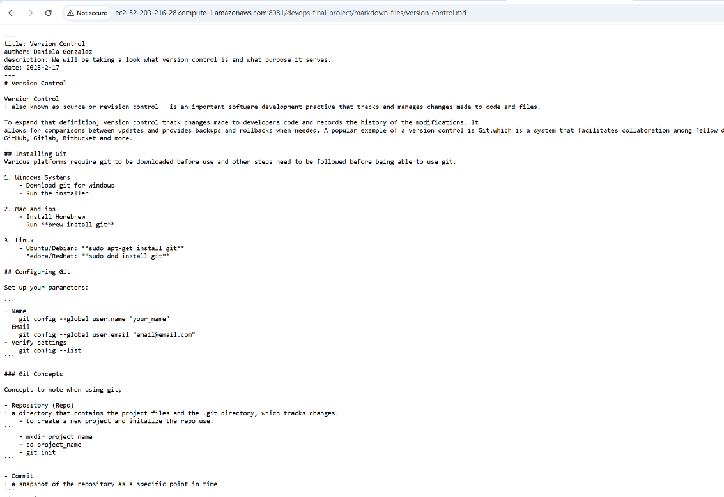
Screenshot 2 | 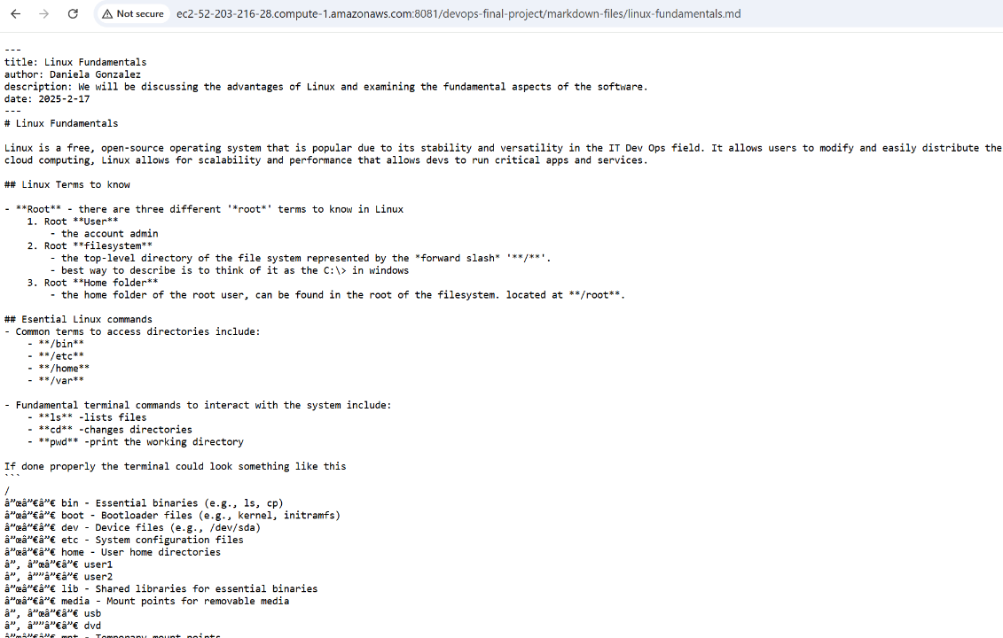
- Upload those screenshots to your S3 bucket.
Screenshot | 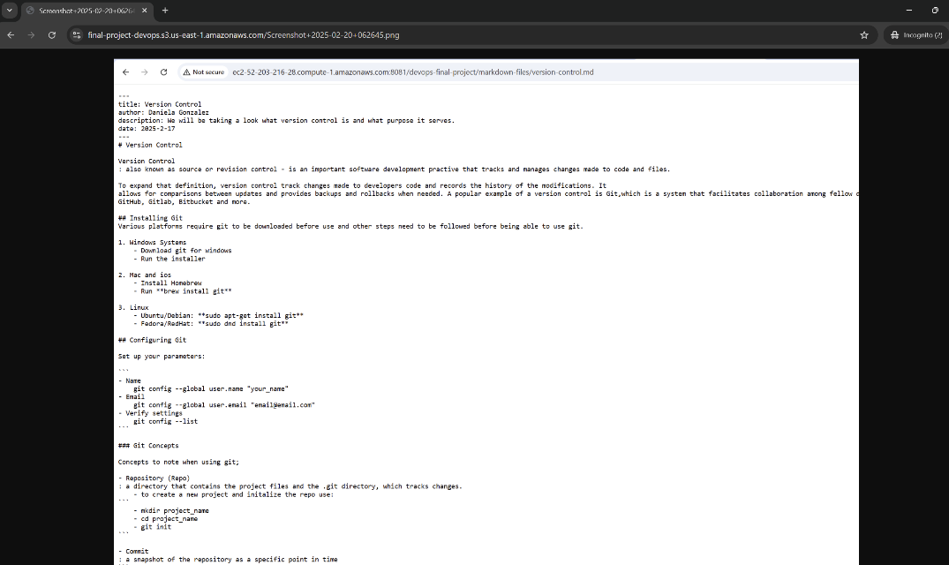  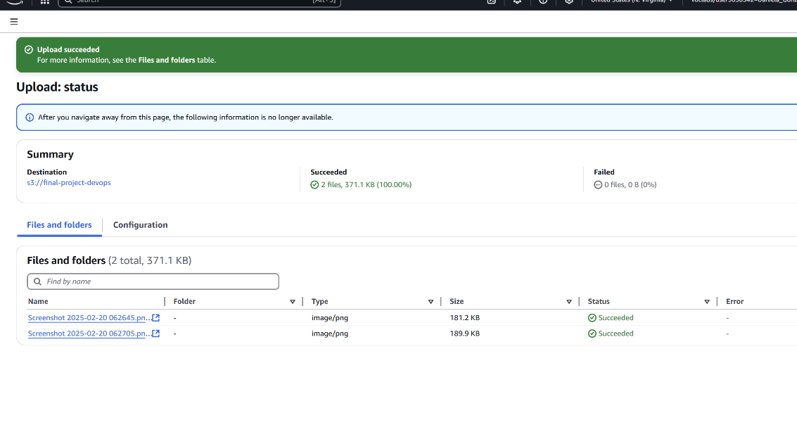
- In your instance repo folder, update your markdown files to include the images you uploaded in S3 (in the markdown reference above there are steps to do this).
- Stage, commit, and push those changes to GitHub.
Screenshot | 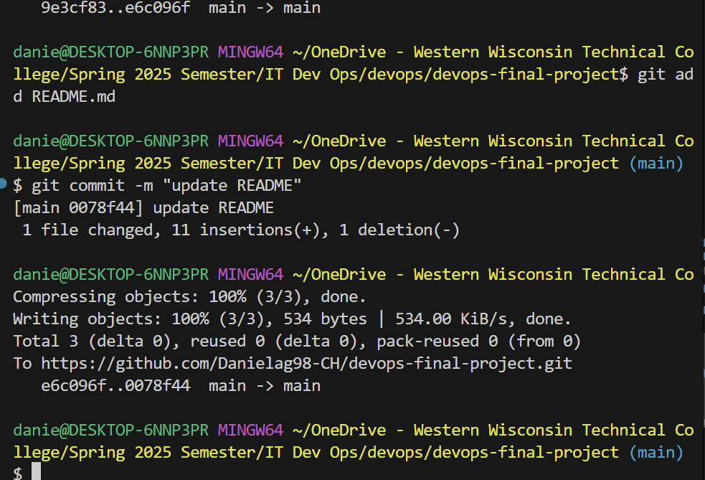  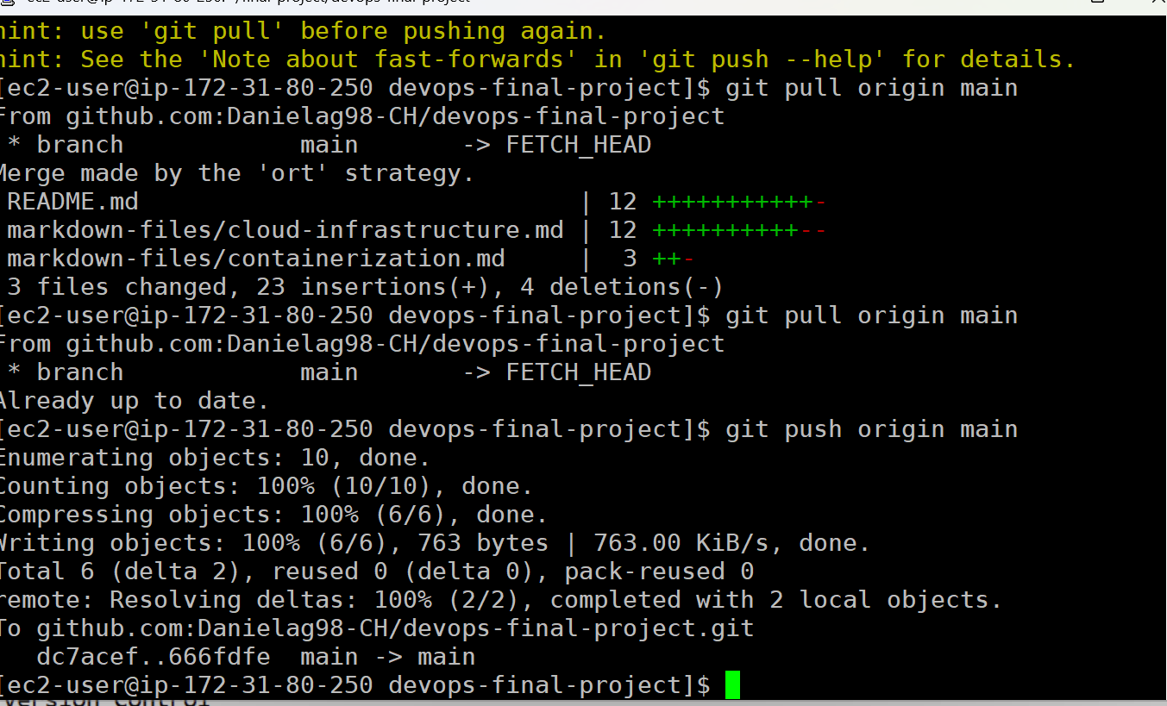
- Refresh your site in the browser to show the included images, which are served from S3.
Screenshot | 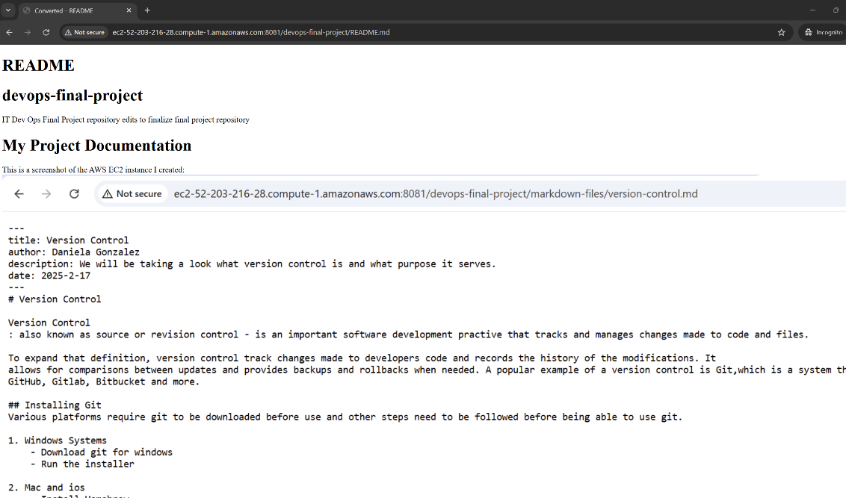
- Run a Content Management System
One of the neat things about Docker, is that we can run more than one web server on a single computer, just on a different port.
- Create a MySQL database container, and have it store the database data in a volume called mysql-final-data. Name the container final-mysql-server.
Screenshot | 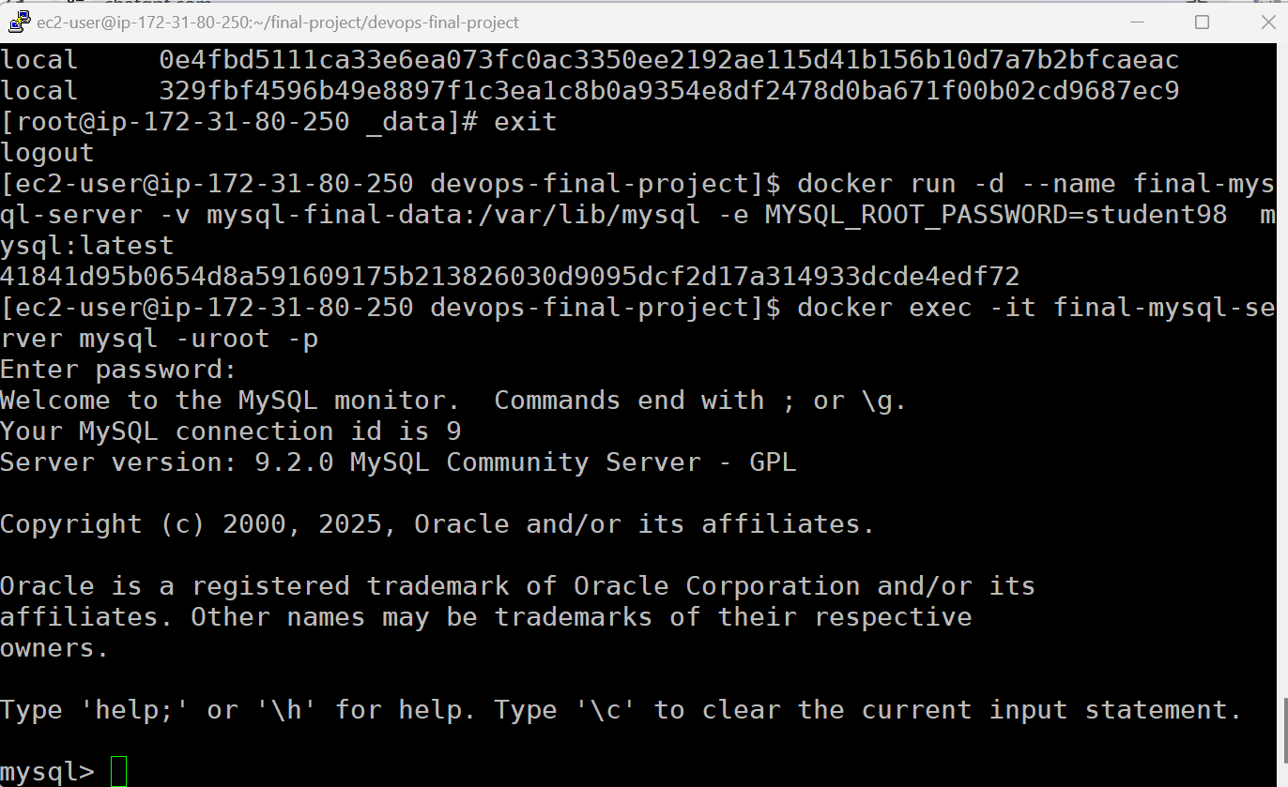
- Enter the command line of final-mysql-server and create a database called cms.
Screenshot | 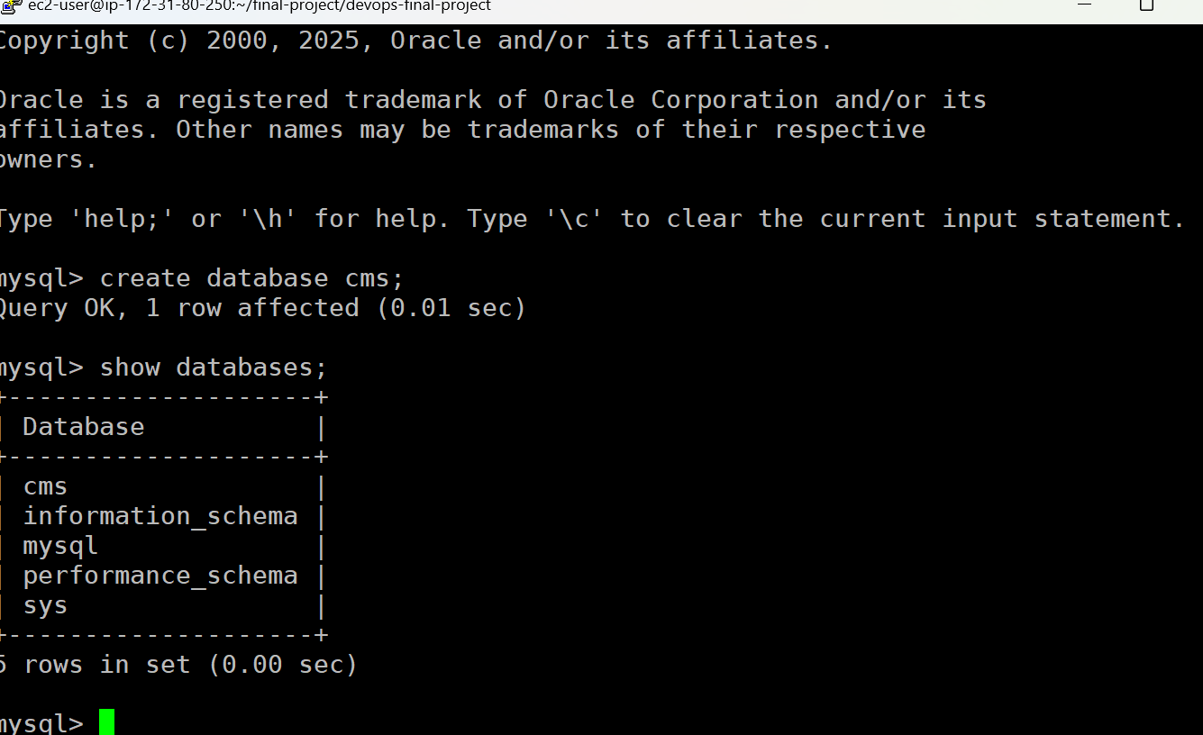
- Create a web server container that runs the CMS Joomla (docker pull joomla), and have it store the html files in a volume called web-final-data and mounted to /var/www/html. Run it on host port 8090 with the name final-web-server.
Screenshot | 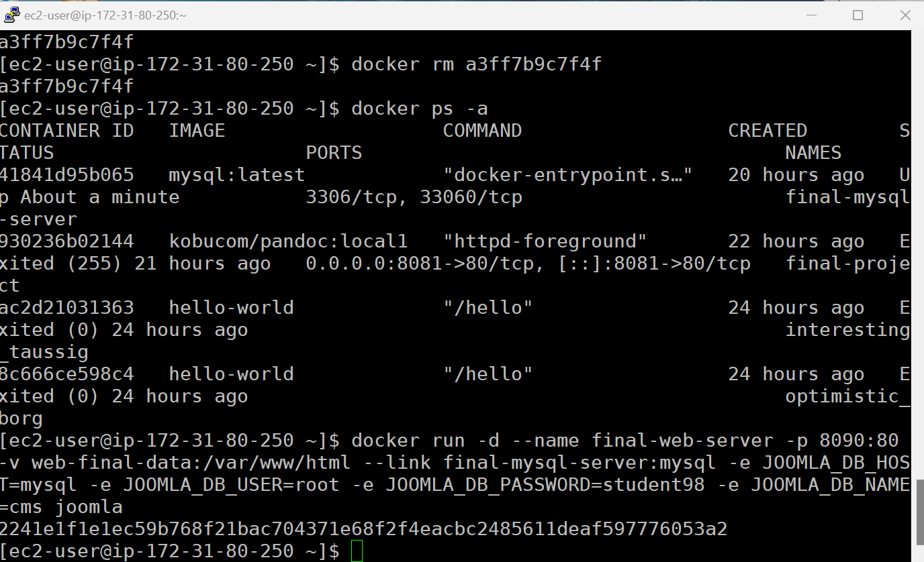
- Navigate to your AWS Public DNS address (HTTP) on port 8090 and proceed through the installation wizard. For the database settings, get the container IP from docker container inspect and use root with the password you chose when creating the database container, and cms as the database.
Screenshot | 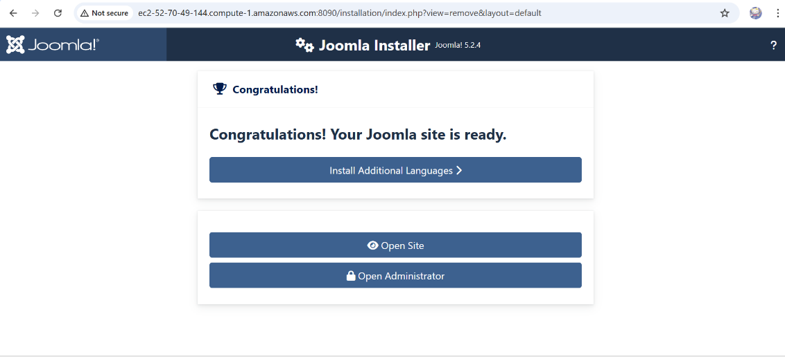
- The installation should complete. Provide a screenshot of the working site.
Screenshot | 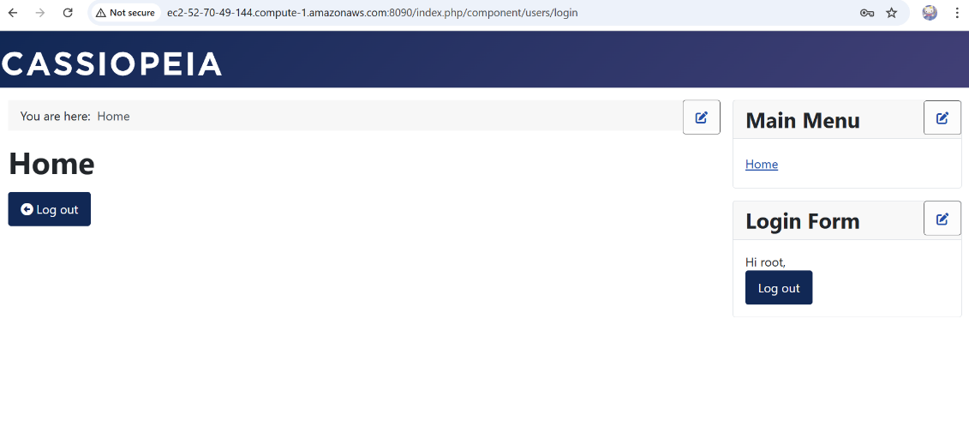
- Tighten Security
In section C we allowed all access to all ports on our instance to be accessible from the internet. We should tighten this up a bit.
- Modify the security group that is attached to the instance to allow only access to SSH and the ports that we are serving through Docker.
Screenshot | 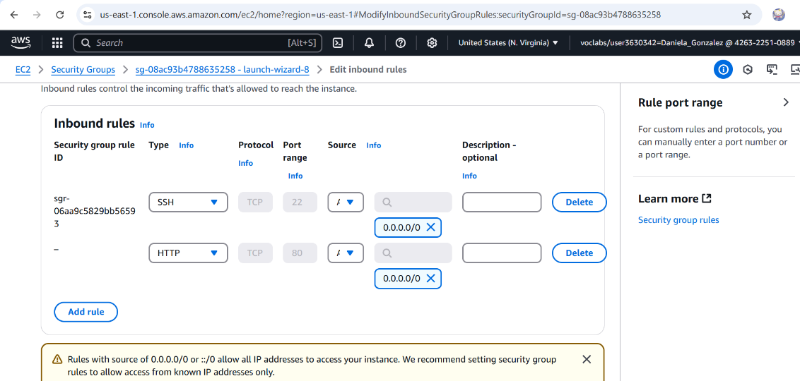
- Reflection
Reflect on your learning journey throughout this course. How have the topics of version control, cloud infrastructure, Linux fundamentals, containerization with Docker, and web and database servers influenced your understanding of modern software development? Which of these topics do you feel most confident with, and which ones would you like to further explore or improve?
Note: This is the final project, so I would like to see at least a couple of paragraphs with your reflection here.
Let's start with the reflection of this final project alone, I will say that I was not anticipating encountering issues that were not explicitly explained in class (at least not that I was aware of). So, when I came across the variances that were in this project, I found myself a bit lost. I seriously struggled with the portion that had me list the S3 bucket screenshots on my README.md file. Thankfully through a lot of help I was finally able to get the site functioning. It took a lot of mistakes to see that what I needed to do was go my git commands in the putty terminal and not VS Studio. The rest after that was fairly straight forward that is until I came across section H, this section is where I can see that I really need much more practice, I made so many mistakes before I finally reached out to my professor.

I find that one thing I need to focus on improving is adapting to changes that are happening. For example, this lab had us use different docker images than what we previously learned to use. That to me was a hurdle that was difficult to overcome but ultimately, I am better for the challenge. And that is true for this entire course, IT Dev Ops has been a challenge in more ways than one for me. It has been an uphill battle changing the way I handle this new knowledge that I learn. As well as an eye opener to the variety of tools I can use in my future career.

Throughout the course of this term I have found that the range of what we were learning really tested my confidence. When we started and the first thing, we used was git and gitHub I thought that this seems easy enough. Boy was I in for more and going into Linux fundamentals I struggled a bit to truely comprehend the information. And it progressively got more challenging to the point that I really struggled with cloud infrastructure and with containerization. Thankfully now being at the end of the term, I find that, though I am not confident in my ability to perform these tasks were I to be given them in the future, I know that all I need is practice to be able to succeed.

Heading into this term I had no idea of what was in store for me for this class. The description of the class was good but left me feeling nervous that I would have a hard time understanding the concepts that we were about to learn. I can confidently say that now after having taken this class I know the basic idea of what we learned, but I will say that I am not confident in my knowledge. Personally, I lack the confidence in myself to see my intellect, but in this case my hesitance stems from lack of practice. I know with certainty, however, that I will gain the confidence needed to perform what is required of me in relation to these topics and look forward to the day that I am confident in my knowledge.

